OOP EXPERIMENT-6

NAME-ANMOL SAP-590011794 BATCH-20
SUBMITTED TO- PROF. Kalluri Shareef Babu

THEORY

Inheritance
Inheritance is a fundamental mechanism in object-oriented programming that enables a class to acquire the properties and behaviors of another class. It is implemented using the extends keyword in Java. This mechanism promotes code reusability, modularity, and hierarchical classification. It facilitates the creation of relationships such as superclass–subclass structures.

Types of Inheritance
Inheritance can be categorized into multiple forms based on structure:
- Single Inheritance: A subclass derives from a single superclass.
- Hierarchical Inheritance: Multiple subclasses inherit from a common superclass.
- Multilevel Inheritance: A chain of inheritance is formed across multiple levels.
These structures improve abstraction and organization of code.

Method Overriding
Method overriding refers to redefining a method in a subclass that is already defined in its superclass. The method signature must remain identical. This mechanism supports runtime polymorphism and dynamic behavior modification.

Runtime Polymorphism (Late Binding)
Runtime polymorphism is the process by which method calls are resolved during execution rather than at compile time. The Java Virtual Machine determines the appropriate method implementation based on the actual object type, enabling dynamic method dispatch.

Dynamic Method Dispatch
Dynamic method dispatch is the process where a superclass reference variable refers to a subclass object, and the method execution is determined at runtime. This allows flexible and extensible program behavior.

super Keyword
The super keyword is used to invoke the constructor or method of the superclass. It enables reuse of parent class functionality and supports hierarchical initialization.

Abstract Classes
Abstract classes are declared using the abstract keyword and cannot be instantiated directly. They may contain both abstract and concrete methods. Subclasses are required to implement abstract methods, ensuring design consistency.

Interfaces
Interfaces define fully abstract behavior and are implemented using the implements keyword. They support multiple inheritance and enforce method contracts in implementing classes.

Multiple Inheritance via Interfaces
Java does not support multiple inheritance using classes due to ambiguity issues. However, multiple inheritance is achieved through interfaces, allowing a class to implement multiple behavioral contracts.

Dynamic Binding
Dynamic binding refers to the resolution of method calls at runtime based on object type. It is a core concept underlying runtime polymorphism.

Type Checking and Casting
The instanceof operator is used for runtime type identification. Typecasting allows access to subclass-specific methods when using superclass references.

Constructor Usage in Inheritance
Constructors in inheritance are invoked using super(). This ensures proper initialization of inherited attributes and avoids redundancy.

Input and Output Handling
- Input is handled using the Scanner class.
- Output is displayed using System.out.print() and System.out.println().

Object Creation and Method Invocation
Objects are instantiated using the new keyword. Method calls are resolved dynamically when polymorphism is involved.

Th1: Why is Runtime Polymorphism also called "Late Binding"?

Runtime Polymorphism is also called Late Binding because the method call doesn't link to its definition at compile time — it happens late, at runtime. When a child object is assigned to a parent reference and an overridden method is called, the compiler only sees the reference type and can't decide which version to run. That decision is made at runtime, when the JVM sees the actual object and binds the call to the correct method — hence the name Late Binding or Dynamic Binding.

Th2: Can you override a static method in Java? Why or why not?

No, you cannot override a static method in Java. The reason is that static methods belong to the class itself, not to any object, so they are resolved at compile time using the reference type, not at runtime using the actual object. This is called static binding or early binding. When you define a static method with the same signature in a subclass, it is not overriding, it is called method hiding. The difference is that in actual overriding, the call is resolved based on the actual object at runtime, but with static methods, even if you hold a child object in a parent reference and call the static method, it will always call the parent's version because the binding already happened at compile time. So since overriding is based on dynamic dispatch which requires runtime resolution, and static methods are resolved at compile time itself, static methods simply cannot be overridden in Java.

Th3: What is the difference between this() and super() calls?

Both `this()` and `super()` are constructor calls but they serve different purposes. `this()` is used to call another constructor of the same class, basically when you have multiple constructors and you want one constructor to reuse the logic of another constructor in the same class, you use `this()`. On the other hand `super()` is used to call the constructor of the parent class from inside the child class constructor, which is what we used in our Bank program when SBI and HDFC called `super(p, si, 3.2)` to initialize the parent Bank's fields. One important rule for both is that they must always be the very first statement inside the constructor, and because of this you can never use both `this()` and `super()` together in the same constructor since only one can be the first statement. Also if you don't write `super()` explicitly, Java automatically inserts a default `super()` call at the start of every child class constructor, but if the parent has no default constructor then you have to call `super()` manually with the right arguments. So basically `this()` is same class constructor to constructor call, and `super()` is child to parent constructor call.

Th4: What happens if you try to override a final method?

If you try to override a final method in Java, you will get a compile time error itself, Java will not even let the program run. The reason is that when you mark a method as `final`, you are basically telling the compiler that this method cannot be changed or overridden by any subclass, it is the final version of that method. So if a subclass tries to define a method with the same name and signature as a final method in the parent class, the compiler immediately throws an error saying something like "cannot override final method". This is actually done on purpose, `final` is used when you want to lock down a method's behavior and make sure no child class can mess with it. Same way if you mark an entire class as `final`, like the `String` class in Java, then that class cannot be extended at all. So basically `final` on a method means the method is closed for overriding, and any attempt to do so is a compile time error not even a runtime one.

Th5: Explain Covariant Return Types in the context of method overriding.

Normally in method overriding the return type of the overriding method in the child class has to exactly match the return type of the method in the parent class. But covariant return type is an exception to this rule where the overriding method in the child class is allowed to return a subtype of the return type declared in the parent class. For example if the parent class method returns a Bank object, the child class can override it and return an SBI object instead, because SBI is a subclass of Bank so it is a more specific or narrower type. This was introduced in Java 5 and the idea behind it is pretty logical, if the parent says "I will return a Bank", the child saying "I will return an SBI" is still valid because SBI is a Bank, it is just more specific. This makes the code cleaner because without covariant return types you would have to return the parent type and then manually cast it to the child type every time you used it. One thing to remember is that this only works one way, the return type can get narrower meaning more specific going from parent to child, but it cannot get broader, so if the parent returns SBI the child cannot override it to return Bank because that would be a wider type and Java won't allow that. So basically covariant return type means the overriding method can return the same type or any subtype of the original return type.

Th6: Is it possible to perform multiple inheritance using classes in Java?

No, Java does not support multiple inheritance using classes, meaning a class cannot extend more than one class at the same time. The reason Java removed this is because of a famous problem called the Diamond Problem. The problem is that if class C extends both class A and class B, and both A and B have a method with the same name, then when C tries to call that method the compiler gets confused about which version to use, A's or B's, and this creates ambiguity. To avoid this confusion entirely Java made a design decision to simply not allow a class to have more than one parent class. However Java does allow multiple inheritance through interfaces, a class can implement any number of interfaces at the same time, and this is the standard way to achieve multiple inheritance like behavior in Java. Earlier this used to have the same diamond problem risk with interfaces too but Java 8 introduced default methods in interfaces which brought that risk back slightly, and Java handles it by forcing the implementing class to override the conflicting method itself if two interfaces have the same default method. So to summarize, multiple inheritance with classes is completely not allowed in Java to avoid the diamond problem, but you can achieve similar behavior using interfaces.

Th7: Can abstract classes have constructors?

Yes, abstract classes can have constructors in Java even though you cannot create an object of an abstract class directly. This confuses a lot of people because they think if you can't instantiate it then what is the point of a constructor in it. The reason is that when a child class extends an abstract class and you create an object of the child class, the child class constructor automatically calls the parent abstract class constructor via `super()`, either explicitly or implicitly. So the constructor of the abstract class is not being called to create an abstract class object, it is being called to initialize the fields and setup the state that belongs to the abstract class portion of the child object. For example if an abstract class has some fields like `p`, `si`, `r` like in our Bank program, those fields need to be initialized somehow when a child like SBI or HDFC is created, and that initialization happens through the abstract class constructor when `super()` is called. So the constructor is basically there to serve the child classes, not to create objects of the abstract class itself. If you try to do `new AbstractClass()` directly Java will throw a compile time error, but the constructor still runs indirectly every time a child class object is created. So yes abstract classes can and often should have constructors for proper field initialization.

Th8: What are Default methods?

Default methods are methods defined inside an interface that have an actual body or implementation, introduced in Java 8. Before Java 8 interfaces could only have abstract methods meaning just the method signature with no body, and any class implementing the interface had to provide the implementation for all those methods. But the problem was that if you had an interface being implemented by hundreds of classes and you wanted to add a new method to that interface, every single class would break because now they all need to implement that new method. To solve this Java 8 introduced default methods where you can define a method directly inside the interface with the `default` keyword and give it a full implementation, and any class that implements the interface automatically inherits that implementation without being forced to override it. The class can still choose to override the default method if it wants its own version, but it is not mandatory. Now the diamond problem risk that was mentioned earlier comes in here, if two interfaces have a default method with the same name and a class implements both of them, Java forces that class to override the conflicting method and provide its own implementation to resolve the ambiguity, otherwise it is a compile time error. So basically default methods were added to allow interfaces to evolve and add new functionality over time without breaking all the existing classes that already implement them, it is more of a backward compatibility feature than anything else.

Th9 Is 'final' allowed for abstract classes?

No, `final` and `abstract` are completely opposite and contradictory keywords in Java so you cannot use them together on a class. The whole purpose of an abstract class is that it is meant to be extended by subclasses, it is incomplete on its own and relies on child classes to provide implementations for its abstract methods. On the other hand the whole purpose of `final` on a class is to prevent it from being extended by anyone. So if you try to write `final abstract class Something` Java will immediately give you a compile time error because you are basically saying "this class must be extended but also cannot be extended" at the same time which makes no sense. Same logic applies to methods as well, an `abstract` method has no body and exists only so that child classes can override and implement it, but a `final` method cannot be overridden at all, so `final abstract` on a method is also completely illegal and will give a compile time error. So the rule is simple, `final` and `abstract` can never be used together whether on a class or a method because their purposes are directly opposite to each other.

Th10: Difference between extends & implements.

Both `extends` and `implements` are used to achieve inheritance in Java but they are used in different situations. `extends` is used when a class wants to inherit from another class, or when an interface wants to inherit from another interface. With `extends` a class can only extend one class at a time because Java does not support multiple inheritance with classes. `implements` on the other hand is used when a class wants to implement an interface, and unlike `extends` a class can implement any number of interfaces at the same time separated by commas. The key difference in behavior is that when you `extend` a class you inherit both the method signatures and their actual implementations, so you get the full working methods from the parent. But when you `implement` an interface you only get the method signatures and you are forced to provide your own implementation for all of them, unless they are default methods. Another difference is that an interface cannot `implement` another interface, it can only `extend` another interface, while a class can never `extend` an interface, it can only `implement` it. So basically `extends` is class to class or interface to interface, and `implements` is class to interface, and the main practical difference is that `extends` gives you one parent with full implementation while `implements` lets you take from multiple interfaces but you have to write the implementations yourself.

Th11: What are Marker Interfaces?

A marker interface is an interface that has no methods and no fields inside it, it is completely empty. The only purpose of a marker interface is to mark or tag a class to signal to the JVM or the compiler that this class has some special property or should be treated in a special way. The most famous examples in Java are `Serializable` and `Cloneable`. When you implement `Serializable` on a class you are not forced to implement any method because there are none, you are simply telling the JVM that objects of this class are allowed to be serialized meaning converted to a byte stream and saved or transferred. If you try to serialize an object of a class that does not implement `Serializable`, the JVM will throw a `NotSerializableException` at runtime. So the interface itself does nothing functionally, it just acts as a flag or a label on the class. Same with `Cloneable`, implementing it tells the JVM that this class permits cloning, without it if you try to call `clone()` on an object you get a `CloneNotSupportedException`. Now with Java 5 annotations came along and many people argue that annotations are a better and more flexible way to tag classes compared to marker interfaces, and that is true to some extent, but marker interfaces are still used in Java and are still an important concept to know. So basically a marker interface is just an empty interface used to tag a class and convey metadata to the JVM about how objects of that class should be handled.

Th12: Can an interface extend another interface?

Yes an interface can extend another interface in Java and it uses the `extends` keyword for this, not `implements`. When an interface extends another interface it inherits all the abstract methods of the parent interface, and any class that implements the child interface is then responsible for providing implementations for all the methods, both the ones defined in the child interface and the ones inherited from the parent interface. This is different from a class extending another class because here there is no actual implementation being inherited, just method signatures, so there is no diamond problem risk with simple abstract methods. Also unlike classes, an interface can extend multiple interfaces at the same time, so you can write `interface C extends A, B` which is perfectly valid in Java. The diamond problem only becomes a concern when default methods are involved, if two parent interfaces have a default method with the same name and a third interface extends both of them, then any class implementing that third interface has to override the conflicting default method to resolve the ambiguity. This ability of interfaces to extend multiple interfaces is actually one of the reasons why Java uses interfaces to simulate multiple inheritance behavior that is not possible with classes. So basically interface extending interface is allowed, uses `extends`, can be multiple, and the implementing class at the end of the chain is responsible for implementing everything.

Th13: Can we define static methods in interfaces?

Yes, static methods are allowed in interfaces in Java and this was also introduced in Java 8 along with default methods. A static method in an interface has a full body and implementation just like a default method, but the key difference is that a static method belongs to the interface itself and not to any implementing class. This means you cannot call a static method of an interface using an object of the implementing class or through the implementing class name, you have to call it directly using the interface name like `InterfaceName.methodName()`. This is very different from default methods which are inherited by the implementing class and can be overridden, static methods in interfaces are not inherited at all by the implementing classes or even by sub interfaces that extend the parent interface. The reason they were added is basically to provide utility or helper methods that are related to the interface and make sense to keep inside the interface itself rather than creating a separate utility class for them. For example if you have a `Bank` interface you could have a static method inside it like a validator or a calculator that is general purpose and related to banking but does not need to be part of every implementing class. So to summarize, yes interfaces can have static methods since Java 8, they have a full body, they belong to the interface itself, they are called using the interface name directly, they are not inherited by implementing classes, and they are mainly used as utility or helper methods related to that interface.

Th14 Define 'Loose Coupling'.

Loose coupling means that classes or components in a program are as independent from each other as possible, meaning a change in one class should have little to no impact on another class. When two classes are tightly coupled it means one class directly depends on the concrete implementation of another class, so if you change something in one you are forced to change the other as well which makes the code rigid and hard to maintain. Loose coupling solves this by making classes depend on abstractions like interfaces or abstract classes instead of concrete implementations. For example instead of writing `SBI s = new SBI()` everywhere in your code, if you write `Bank b = new SBI()` and work with the `Bank` reference, the rest of your code does not care whether the actual object is SBI or HDFC or any other bank, you can swap the implementation without touching anything else. This is exactly why interfaces are so heavily used in real world Java projects, they act as a contract between classes so that the classes interact through the interface and do not need to know anything about each other's internal implementation. Loose coupling makes code easier to maintain, easier to test, easier to extend, and easier to scale because individual components can be changed or replaced independently without breaking the whole system. So basically loose coupling is about minimizing direct dependencies between classes by programming to abstractions rather than concrete implementations, and it is one of the most important principles of good object oriented design.

Exp 6.1
//Write a Java program to demonstrate single inheritance using class Person and subclass Student Override a method display() in the subclass
class Person
{
void display()
{
System.out.println("This is a person.");
}
}
class Student extends Person
{
void display()
{
System.out.println("This is a student.");
}
}
public class exe6_1
{
public static void main(String[] args)
{
Person p=new Person();
p.display();
Student s=new Student();
s.display();
}
}
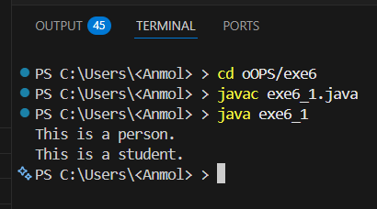
Observation: In the above code, we have a superclass Person with a method display() that prints "This is a person." The subclass Student extends Person and overrides the display() method to print "This is a student." In the main method, we create an instance of Person and call the display() method, which outputs "This is a person." Then we create an instance of Student and call the display() method, which outputs "This is a student." This demonstrates single inheritance and method overriding in Java.

Exp 6.2
//Develop a Java program to implement runtime polymorphism using class Shape and subclass Circle.
Override the method area().
class Shape
{
void area()
{
System.out.println("Area of shape");
}
}
class Circle extends Shape
{
void area()
{
System.out.println("Area of circle");
}
}
public class exe6_2
{
public static void main(String[] args)
{
Shape s=new Shape();
s.area();
Circle c=new Circle();
c.area();
}
}
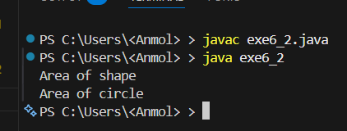
Observation: In the above code, we have a superclass Shape with a method area() that prints "Area of shape." The subclass Circle extends Shape and overrides the area() method to print "Area of circle." In the main method, we create an instance of Shape and call the area() method, which outputs "Area of shape." Then we create an instance of Circle and call the area() method, which outputs "Area of circle." This demonstrates runtime polymorphism and method overriding in Java as the method that gets called is determined at runtime based on the object type.

Exp 6.3
//Write a Java program to demonstrate hierarchical inheritance using class Vehicle and subclasses Car and Bike.
class Vehicle
{
void display()
{
System.out.println("This is a vehicle.");
}
}
class Car extends Vehicle
{
void display()
{
System.out.println("This is a car.");
}
}
class Bike extends Vehicle
{
void display()
{
System.out.println("This is a bike.");
}
}
public class exe6_3
{
public static void main(String[] args)
{
Vehicle v=new Vehicle();
v.display();
Car c=new Car();
c.display();
Bike b=new Bike();
b.display();
}
}
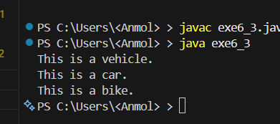
Observation: In the above code, we have a superclass Vehicle with a method display() that prints "This is a vehicle." The subclasses Car and Bike extend Vehicle and override the display() method to print "This is a car." and "This is a bike." respectively. In the main method, we create an instance of Vehicle and call the display() method, which outputs "This is a vehicle." Then we create an instance of Car and call the display() method, which outputs "This is a car." Finally, we create an instance of Bike and call the display() method, which outputs "This is a bike." This demonstrates hierarchical inheritance in Java as both Car and Bike inherit from the same superclass Vehicle.

Exp 6.4
// Implement a Java program to demonstrate method overriding using class Bank and subclasses SBI and HDFC to compute interest rates
import java.util.Scanner;
class Bank
{
double p,si,r,t;
Bank(double p,double si,double t)
{
this.p=p;
this.si=si;
this.t=t;
r=(si*100)/(p*t);
}
void interest()
{
System.out.println("Interest rate of bank is:"+r+"% for time: "+t+" years");
}
}
class SBI extends Bank
{
SBI(double p,double si)
{
super(p,si,3.2);
}
void interest()
{
System.out.println("Interest rate of SBI is: "+r+"% for time: "+t+" years");
}
}
class HDFC extends Bank
{
HDFC(double p,double si)
{
super(p,si,5.6);
}
void interest()
{
System.out.println("Interest rate of HDFC is: "+r+"% for time: "+t+" years");
}
}
public class exe6_4
{
public static void main(String[] args)
{
Scanner sc=new Scanner(System.in);
System.out.print("Enter principal amount: ");
double p=sc.nextDouble();
System.out.print("Enter simple interest: ");
double si=sc.nextDouble();
Bank b=new Bank(p,si,2);
b.interest();
SBI s=new SBI(p,si);
s.interest();
HDFC h=new HDFC(p,si);
h.interest();
}
}

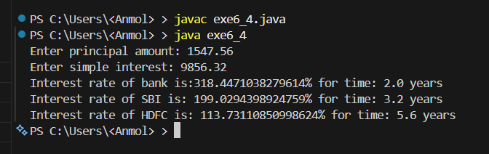

Observation: In the above code, we have a superclass Bank with a constructor that calculates the interest rate based on the principal amount (p) and simple interest (si) taken as user input. The subclasses SBI and HDFC extend Bank and override the interest() method to display the interest rates specific to each bank using their fixed time values (3.2 and 5.6 respectively). In the main method, we take p and si from the user via Scanner, create instances of Bank, SBI, and HDFC with those values, and call their interest() methods. This demonstrates method overriding in Java with dynamic user input.

Exp 6.5
//Write a Java program to demonstrate multilevel inheritance using classes Employee → Manager → Director.
class Employee
{
void display()
{
System.out.println("This is an employee.");
}
}
class Manager extends Employee
{
void display()
{
System.out.println("This is a manager.");
}
}
class Director extends Manager
{
void display()
{
System.out.println("This is a director.");
}
}
public class exe6_5
{
public static void main(String[] args)
{
Employee e=new Employee();
e.display();
Manager m=new Manager();
m.display();
Director d=new Director();
d.display();
}
}
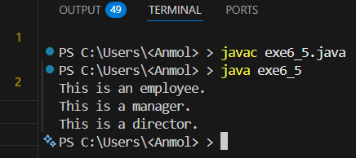
Observation: In the above code, we have a superclass Employee with a method display() that prints "This is an employee." The subclass Manager extends Employee and overrides the display() method to print "This is a manager." The subclass Director extends Manager and overrides the display() method to print "This is a director." In the main method, we create an instance of Employee and call the display() method, which outputs "This is an employee." Then we create an instance of Manager and call the display() method, which outputs "This is a manager." Finally, we create an instance of Director and call the display() method, which outputs "This is a director." This demonstrates multilevel inheritance and method overriding in Java.

Exp 6.6
//Develop a Java program to demonstrate runtime polymorphism using an array of objects. Use class Animal and subclasses Dog and Cat.
class Animal
{
void sound()
{
System.out.println("Animal makes a sound");
}
}
class Dog extends Animal
{
void sound()
{
System.out.println("Dog barks");
}
}
class Cat extends Animal
{
void sound()
{
System.out.println("Cat meows");
}
}
public class exe6_6
{
public static void main(String args[])
{
Animal[] animals=new Animal[3];
animals[0]=new Animal();
animals[1]=new Dog();
animals[2]=new Cat();
for (Animal animal:animals)
{
animal.sound();
}
}
}
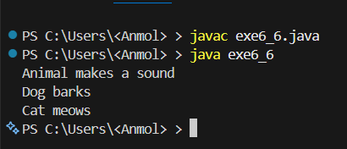
Observation: In the above code, we have a superclass Animal with a method sound() that prints "Animal makes a sound." The subclasses Dog and Cat extend Animal and override the sound() method to print "Dog barks" and "Cat meows" respectively. In the main method, we create an array of Animal objects and assign instances of Animal, Dog, and Cat to it. We then use a for-each loop to iterate through the array and call the sound() method on each object. This demonstrates runtime polymorphism in Java, as the method that gets called is determined at runtime based on the actual object type (Animal, Dog, or Cat) rather than the reference type (Animal).

Exp 6.7
//Write a Java program to demonstrate dynamic method dispatch using user input. Create base class Shape and subclasses Circle and Square.
import java.util.Scanner;
class Shape
{ void area()
{
System.out.println("Area of shape");
}
}
class Circle extends Shape
{ void area()
{
System.out.println("Area of circle");
}
}
class Square extends Shape
{ void area()
{
System.out.println("Area of square");
}
}
public class exe6_7
{
public static void main(String[] args)
{
Scanner sc=new Scanner(System.in);
System.out.print("Enter shape (circle/square): ");
String shape=sc.nextLine();
Shape s;
if(shape.equalsIgnoreCase("circle"))
{
s=new Circle();
s.area();
}
else if(shape.equalsIgnoreCase("square"))
{
s=new Square();
s.area();
}
else
{
System.out.println("Invalid shape");
}
}
}
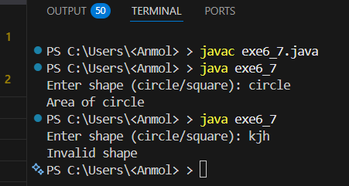
Observation: In the above code, we have a superclass Shape with a method area() that prints "Area of shape." The subclasses Circle and Square extend Shape and override the area() method to print "Area of circle" and "Area of square" respectively. In the main method, we take user input to determine which shape's area method to call. Based on the user's input, we create an instance of either Circle or Square and call the area() method, demonstrating dynamic method dispatch in Java. If the user enters "circle", it will output "Area of circle". If the user enters "square", it will output "Area of square". If the user enters an invalid shape, it will output "Invalid shape". This shows how the method that gets called is determined at runtime based on the object type created from user input.

Exp 6.8
//Design a Java program to demonstrate method overriding using the super keyword. Create base class Vehicle and subclass Car where overridden method calls parent method.
class Vehicle
{
void display()
{
System.out.println("This is a vehicle.");
}
}
class Car extends Vehicle
{
void display()
{
super.display();
System.out.println("This is a car.");
}
}
public class exe6_8
{
public static void main(String[] args)
{
Car c=new Car();
c.display();
}
}
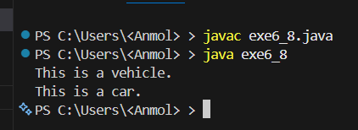
Observation: In the above code, we have a superclass Vehicle with a method display() that prints "This is a vehicle." The subclass Car extends Vehicle and overrides the display() method to first call the parent method using super.display(), which outputs "This is a vehicle." Then it prints "This is a car." In the main method, we create an instance of Car and call the display() method, which demonstrates method overriding and the use of the super keyword to call the parent class method in Java.

Exp 6.9
// Create an abstract class Employee with abstract method calculateSalary(). Implement subclasses Manager and Developer and override the method.
import java.util.Scanner;
abstract class Employee
{
abstract double calculateSalary();
}
class Manager extends Employee
{
double baseSalary;
Manager(double baseSalary)
{
this.baseSalary=baseSalary;
}
double calculateSalary()
{
return baseSalary+5000;
}
}
class Developer extends Employee
{
double baseSalary;
Developer(double baseSalary)
{
this.baseSalary=baseSalary;
}
double calculateSalary()
{
return baseSalary+3000;
}
}
public class exe6_9
{
public static void main(String[] args)
{
Scanner sc=new Scanner(System.in);
System.out.print("Enter manager base salary: ");
double ms=sc.nextDouble();
System.out.print("Enter developer base salary: ");
double ds=sc.nextDouble();
Employee manager=new Manager(ms);
Employee developer=new Developer(ds);
System.out.println("Manager Salary: "+manager.calculateSalary());
System.out.println("Developer Salary: "+developer.calculateSalary());
}
}

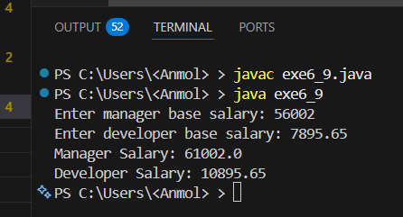
Observation: In the above code, we have an abstract class Employee with an abstract method calculateSalary(). The subclasses Manager and Developer extend Employee and override calculateSalary() to return the base salary plus their respective bonuses of 5000 and 3000. In the main method, base salaries are taken as user input via Scanner, and Employee references are used to hold Manager and Developer objects, demonstrating runtime polymorphism along with abstract classes.

Exp 6.10
// Design an interface Shape with method area(). Implement classes Circle, Rectangle, and Triangle.
import java.util.Scanner;
interface Shape
{
double area();
}
class Circle implements Shape
{
double radius;
Circle(double radius)
{
this.radius=radius;
}
public double area()
{
return Math.PI*radius*radius;
}
}
class Rectangle implements Shape
{
double length,width;
Rectangle(double length,double width)
{
this.length=length;
this.width=width;
}
public double area()
{
return length*width;
}
}
class Triangle implements Shape
{
double base,height;
Triangle(double base,double height)
{
this.base=base;
this.height=height;
}
public double area()
{
return 0.5*base*height;
}
}
public class exe6_10
{
public static void main(String[] args)
{
Scanner sc=new Scanner(System.in);
System.out.print("Enter radius of circle: ");
double r=sc.nextDouble();
System.out.print("Enter length and width of rectangle: ");
double l=sc.nextDouble();
double w=sc.nextDouble();
System.out.print("Enter base and height of triangle: ");
double b=sc.nextDouble();
double h=sc.nextDouble();
Shape circle=new Circle(r);
Shape rectangle=new Rectangle(l,w);
Shape triangle=new Triangle(b,h);
System.out.println("Area of Circle: "+circle.area());
System.out.println("Area of Rectangle: "+rectangle.area());
System.out.println("Area of Triangle: "+triangle.area());
}
}

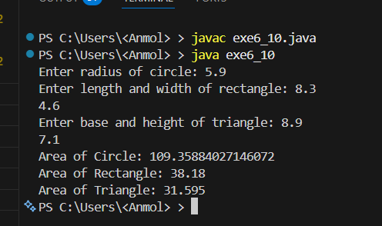
Observation: In the above code, we have an interface Shape with a method area(). The classes Circle, Rectangle, and Triangle implement the Shape interface and provide their own implementation of the area() method. In the main method, we take user input for the dimensions of each shape and create instances of Circle, Rectangle, and Triangle using Shape references. We then call the area() method on each shape, demonstrating polymorphism through interfaces. Each shape calculates its area based on its specific formula, and the results are printed to the console.

Exp 6.11
//Create an abstract class Vehicle with abstract method start() and Implement subclasses Car and Bike demonstrating runtime polymorphism
import java.util.Scanner;
abstract class Vehicle
{
abstract void start();
}
class Car extends Vehicle
{ void start()
{
System.out.println("Car is starting with a key.");
}
}
class Bike extends Vehicle
{
void start()
{
System.out.println("Bike is starting with a button.");
}
}
public class exe6_11
{
public static void main(String[] args)
{
Scanner sc=new Scanner(System.in);
System.out.print("Enter vehicle (car/bike): ");
String vehicle=sc.nextLine();
Vehicle v;
if(vehicle.equalsIgnoreCase("car"))
{
v=new Car();
v.start();
}
else if(vehicle.equalsIgnoreCase("bike"))
{
v=new Bike();
v.start();
}
else
{
System.out.println("Invalid vehicle");
}
}
}

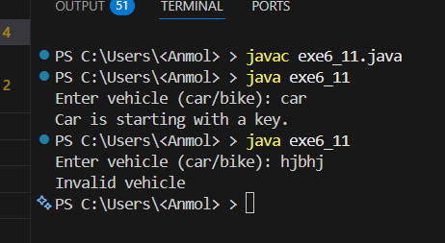
Observation: In the above code, we have an abstract class Vehicle with an abstract method start(). The subclasses Car and Bike extend Vehicle and override the start() method to print a specific message for each vehicle. In the main method, we take user input to determine which vehicle's start method to call. Based on the user's input, we create an instance of either Car or Bike and call the start() method, demonstrating runtime polymorphism in Java with user input

Exp 6.12
//Write a Java program to demonstrate interface-based runtime polymorphism using Payment interface and classes CreditCard and UPI
import java.util.Scanner;
interface Payment
{
void pay(double amount);
}
class CreditCard implements Payment
{
public void pay(double amount)
{
System.out.println("Paid "+amount+" using Credit Card.");
}
}
class UPI implements Payment
{
public void pay(double amount)
{
System.out.println("Paid "+amount+" using UPI.");
}
}
public class exe6_12
{
public static void main(String[] args)
{
Scanner sc=new Scanner(System.in);
System.out.print("Enter payment method (credit/upi): ");
String method=sc.nextLine();
System.out.print("Enter amount to pay: ");
double amount=sc.nextDouble();
Payment payment;
if(method.equalsIgnoreCase("credit"))
{
payment=new CreditCard();
payment.pay(amount);
}
else if(method.equalsIgnoreCase("upi"))
{
payment=new UPI();
payment.pay(amount);
}
else
{
System.out.println("Invalid payment method");
}
}
}
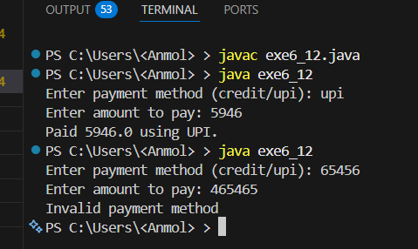
Observation: In the above code, we have an interface Payment with a method pay(). The classes CreditCard and UPI implement the Payment interface and provide their own implementation of the pay() method. In the main method, we take user input to determine which payment method to use and the amount to pay. Based on the user's input, we create an instance of either CreditCard or UPI using Payment references and call the pay() method, demonstrating interface-based runtime polymorphism in Java with user input.

Exp 6.13
//Create an interface Drawable and demonstrate hierarchical implementation
using classes Circle and Square.
import java.util.Scanner;
interface Drawable
{
void draw();
}
class Circle implements Drawable
{
public void draw()
{
System.out.println("Drawing a Circle.");
}
}
class Square implements Drawable
{
public void draw()
{
System.out.println("Drawing a Square.");
}
}
public class exe6_13
{
public static void main(String[] args)
{
Scanner sc=new Scanner(System.in);
System.out.print("Enter shape to draw (circle/square): ");
String shape=sc.nextLine();
Drawable d;
if(shape.equalsIgnoreCase("circle"))
{
d=new Circle();
d.draw();
}
else if(shape.equalsIgnoreCase("square")) {
d=new Square();
d.draw();
}
else
{
System.out.println("Invalid shape");
}
}
}

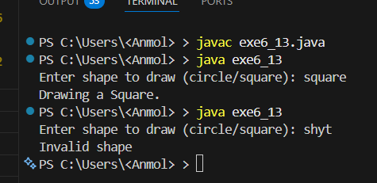
Observation: In the above code, we have an interface Drawable with a method draw(). The classes Circle and Square implement the Drawable interface and provide their own implementation of the draw() method. In the main method, we take user input to determine which shape to draw. Based on the user's input, we create an instance of either Circle or Square using Drawable references and call the draw() method, demonstrating hierarchical implementation of interfaces in Java with user input. Each shape's draw() method prints a specific message to the console, indicating which shape is being drawn.

Exp 6.14
// Design an abstract class Bank with method getInterestRate(). Implement subclasses SBI, HDFC, and ICICI. Demonstrate runtime polymorphism using array of objects.
import java.util.Scanner;
abstract class Bank
{
double p,si,r,t;
Bank(double p,double si,double t)
{
this.p=p;
this.si=si;
this.t=t;
r=(si*100)/(p*t);
}
abstract void getInterestRate();
}
class SBI extends Bank
{
SBI(double p,double si)
{
super(p,si,3.2);
}
public void getInterestRate()
{
System.out.println("Interest rate of SBI is: "+r+"% for time: "+t+" years");
}
}
class HDFC extends Bank
{
HDFC(double p,double si)
{
super(p,si,5.6);
}
public void getInterestRate()
{
System.out.println("Interest rate of HDFC is: "+r+"% for time: "+t+" years");
}
}
class ICICI extends Bank
{
ICICI(double p,double si)
{
super(p,si,4.1);
}
public void getInterestRate()
{
System.out.println("Interest rate of ICICI is: "+r+"% for time: "+t+" years");
}
}
public class exe6_14
{
public static void main(String[] args)
{
Scanner sc=new Scanner(System.in);
System.out.print("Enter principal amount: ");
double p=sc.nextDouble();
System.out.print("Enter simple interest: ");
double si=sc.nextDouble();
Bank b[]=new Bank[3];
b[0]=new SBI(p,si);
b[1]=new HDFC(p,si);
b[2]=new ICICI(p,si);
for(int i=0;i<b.length;i++)
{
b[i].getInterestRate();
}
}
}

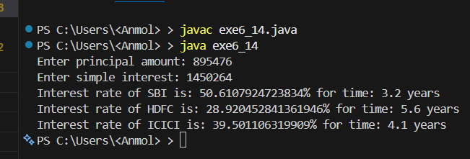
Observation: In the above code, we have an abstract class Bank with a constructor that calculates the interest rate based on user input principal amount (p) and simple interest (si). The subclasses SBI, HDFC, and ICICI extend Bank and override getInterestRate() to display their respective interest rates using fixed time values of 3.2, 5.6, and 4.1 years. In the main method, we take p and si from the user via Scanner, create an array of Bank references holding SBI, HDFC, and ICICI objects, and iterate over it calling getInterestRate() on each element. This demonstrates runtime polymorphism as the correct overridden method is called based on the actual object type at runtime.

Exp 6.15
// Create two interfaces Printer and Scanner. Design class AllInOnePrinter implementing both interfaces. Demonstrate multiple inheritance using interfaces.
interface Printer
{
void print();
}
interface Scanner
{
void scan();
}
class AllInOnePrinter implements Printer,Scanner
{
public void print()
{
System.out.println("Printing document...");
}
public void scan()
{
System.out.println("Scanning document...");
}
}
public class exe6_15
{
public static void main(String[] args)
{
AllInOnePrinter aip=new AllInOnePrinter();
aip.print();
aip.scan();
}
}

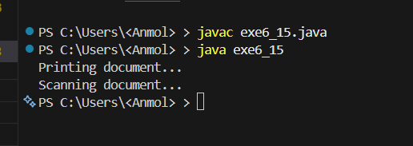
Observation: In the above code, we have two interfaces Printer and Scanner with methods print() and scan() respectively. The class AllInOnePrinter implements both interfaces and provides implementations for both methods. In the main method, we create an instance of AllInOnePrinter and call both print() and scan() methods, demonstrating multiple inheritance using interfaces in Java. The output will show messages indicating that the document is being printed and scanned, showcasing the functionality of both interfaces in a single class.

Exp 6.16
//Design an abstract class Appliance with method powerConsumption()Implement subclasses Fan, AC, and RefrigeratorCompute total power consumption using dynamic binding.
import java.util.Scanner;
abstract class Appliance
{
abstract double powerConsumption();
}
class Fan extends Appliance
{ double power;
Fan(double power)
{
this.power=power;
}
double powerConsumption()
{
return power;
}
}
class AC extends Appliance
{ double power;
AC(double power)
{
this.power=power;
}
double powerConsumption()
{
return power;
}
}
class Refrigerator extends Appliance
{ double power;
Refrigerator(double power)
{
this.power=power;
}
double powerConsumption()
{
return power;
}
}
public class exe6_16
{
public static void main(String[] args)
{
Scanner sc=new Scanner(System.in);
System.out.print("Enter power consumption of fan: ");
double fanPower=sc.nextDouble();
System.out.print("Enter power consumption of AC: ");
double acPower=sc.nextDouble();
System.out.print("Enter power consumption of refrigerator: ");
double fridgePower=sc.nextDouble();
Appliance appliances[]=new Appliance[3];
appliances[0]=new Fan(fanPower);
appliances[1]=new AC(acPower);
appliances[2]=new Refrigerator(fridgePower);
double totalPower=0;
for(Appliance a: appliances)
{
totalPower+=a.powerConsumption();
}
System.out.println("Total power consumption: "+totalPower+" watts");
}
}

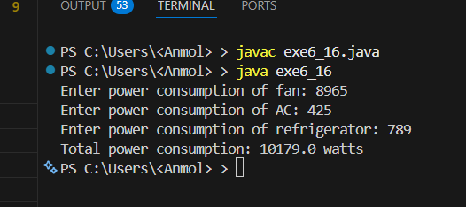
Observation: In the above code, we have an abstract class Appliance with an abstract method powerConsumption(). The subclasses Fan, AC, and Refrigerator extend Appliance and override powerConsumption() to return their respective power consumption values. In the main method, we take user input for the power consumption of each appliance, create an array of Appliance references holding Fan, AC, and Refrigerator objects, and iterate over it to calculate the total power consumption. This demonstrates runtime polymorphism as the correct overridden method is called based on the actual object type at runtime, allowing us to compute the total power consumption dynamically.

Exp 6.17
//Design a Bank Transaction System:
// Abstract class → Account
// Interfaces → Loan, Insurance
// Classes → SavingsAccount, CurrentAccount
// The program should demonstrate:
// Multiple inheritance using interfaces
// Runtime polymorphism
// Array of objects
// Menu-driven execution
import java.util.Scanner;
abstract class Account
{
double bal;
Account(double b)
{
bal=b;
}
abstract void dep(double a);
abstract void wit(double a);
}
interface Loan
{
void loan(double a);
}
interface Insurance
{
void ins(double a);
}
class SavingsAccount extends Account implements Loan
{
SavingsAccount(double b)
{
super(b);
}
void dep(double a)
{
bal+=a;
}
void wit(double a)
{
if(a<=bal) bal-=a;
else System.out.println("Insufficient");
}
public void loan(double a)
{
System.out.println("Loan "+a+" applied");
}
}
class CurrentAccount extends Account implements Insurance
{
CurrentAccount(double b)
{
super(b);
}
void dep(double a)
{
bal+=a;
}
void wit(double a)
{
if(a<=bal) bal-=a;
else System.out.println("Insufficient");
}
public void ins(double a)
{
System.out.println("Insurance "+a+" bought");
}
}
public class exe6_17
{
public static void main(String[] args)
{
Scanner sc=new Scanner(System.in);
Account acc[]=new Account[2];
acc[0]=new SavingsAccount(0);
acc[1]=new CurrentAccount(0);
int ch,i;
double a;
while(true)
{
System.out.println("\n1.Deposit 2.Withdraw 3.Loan 4.Insurance 5.Show 6.Exit");
System.out.print("Enter choice: ");
ch=sc.nextInt();
if(ch==6) break;
System.out.print("Account (1/2): ");
i=sc.nextInt()-1;
if(i<0||i>1)
{
System.out.println("Invalid account");
continue;
}
switch(ch)
{
case 1:
System.out.print("Amount: ");
a=sc.nextDouble();
acc[i].dep(a);
break;
case 2:
System.out.print("Amount: ");
a=sc.nextDouble();
acc[i].wit(a);
break;
case 3:
if(acc[i] instanceof SavingsAccount)
{
System.out.print("Loan amt: ");
a=sc.nextDouble();
((SavingsAccount)acc[i]).loan(a);
}
else System.out.println("Not allowed");
break;
case 4:
if(acc[i] instanceof CurrentAccount)
{
System.out.print("Insurance amt: ");
a=sc.nextDouble();
((CurrentAccount)acc[i]).ins(a);
}
else System.out.println("Not allowed");
break;
case 5:
System.out.println("Balance: "+acc[i].bal);
break;
default:
System.out.println("Invalid");
}
}
}
}
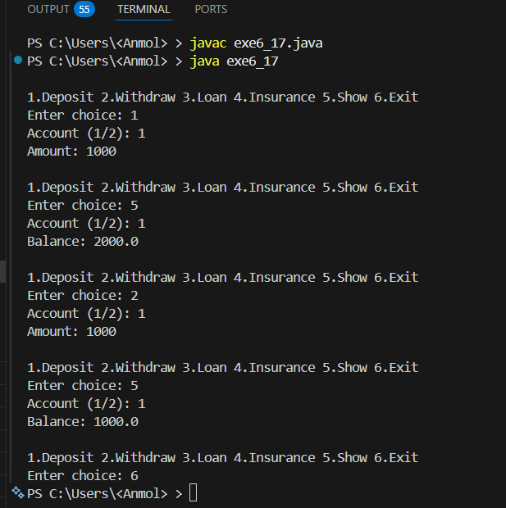
Observation: In the above code, we have an abstract class Account with a constructor that initializes the balance (bal) and abstract methods dep() and wit() for deposit and withdrawal. We have two interfaces, Loan and Insurance, with methods loan() and ins() respectively. The SavingsAccount class extends Account and implements Loan, while the CurrentAccount class extends Account and implements Insurance. In the main method, we create an array of Account objects to hold instances of SavingsAccount and CurrentAccount. We then use a menu-driven approach to perform various operations like deposit, withdraw, apply for a loan, buy insurance, and show balance. This demonstrates multiple inheritance using interfaces, runtime polymorphism through method overriding, and the use of an array of objects to manage different account types in a bank transaction system in Java.

